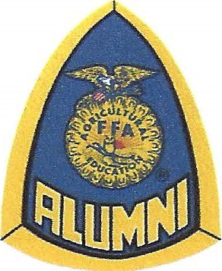
Mansfield FFA Alumni Association Scholarship Application

GENERAL INFORMATION
Name of Applicant:
Address:
Telephone Number:
Age: Date of Birth:
Fathers Name:
Mothers Name:
High School Attending:
College or Trade School to Attend
Date application Submitted:

APPLICATIONS MUST BE TYPED AND TURNED IN WITH FULL DOCUMENTATION TO MR. BETHEL ON OR BEFORE MARCH 26TH BY 3PM. INCOMPLETE APPLICATIONS WILL NOT BE JUDGED OR ELIGIBLE FOR CONSIDERATION. NO LATE APPLICATIONS ACCEPTED.
APPLICATION REQUIREMENTS:
- Completed application
- Letter of Recommendation from a non-AG teacher and a non-family member. Needs to be an outside source. (Minimum of 1 letter, but can have a maximum of 3 letters.)
- Resume’ – highlighting AG and FFA participation, activities, positions held and awards
- Unofficial transcript
- Essay on specific topic (Topics are listed below)
- All supporting documentation for the resume’
- Attestation document signed by applicant

ESSAY TOPICS:

Choose one of the following topics to write your essay on.

- Who is the person that has been the biggest influence in your life and why?
- What I do Best, My Biggest Success
- ‘I can. We will.’ What does this mean to you and how will you apply it in your future ag career?

QUALIFICATION CRITERIA
The applicant must have met the following qualifications in order to be considered as a recipient:
STUDENT:
- Graduating Senior of the current year of scholarship application.
- Member of the Mansfield FFA Chapter for a minimum of 2 years(senior year and minimum of one other). A member in good standing in accordance with the Mansfield FFA Chapter (verified by the FFA student advisor) during the years that you were a member. If you transferred into Mansfield during your Junior or Senior year, provide documentation from your former school of your FFA involvement.
- To receive your scholarship, you will have to provide a proof of your diploma.

The above minimum qualifications will qualify you to apply for FFA Alumni scholarship. The awarding of, and amount of all scholarships will depend on the amount of money the Alumni Association has available from year to year.
Consideration for a FFA Alumni Scholarship, you must submit this application according to the criteria listed.

SCHOLARSHIP DISBURSEMENT

Who gets what?
Fifty percent (50%) of the students, from the group of completed and approved applications, will receive a scholarship from the FFA Alumni.
Breakdown of awards:
1st – Thirty percent (30%) of allotted scholarship fund
2nd – Twenty percent (20%) of allotted scholarship fund
3rd – Fifteen percent (15%) of allotted scholarship fund
4th - Remaining number of eligible students from the fifty percent (50%) – equally divided amount remaining after the top three prizes.

ADDITIONAL INFORMATION:
- When taking the fifty percent of eligible senior applications, odd numbers will be rounded up. (i.e. 19 eligible senior applications which 50% would be 9.5 seniors. This would be rounded up to ten seniors to receive a FFA Alumni scholarship.)
- An independent committee of five (5) people selected by the FFA Alumni will judge scholarship applications.

